Official league roster - Soccer
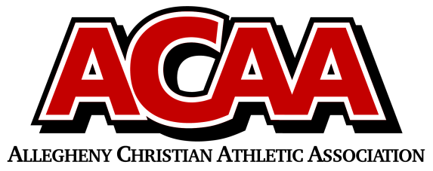

School Name: Columbia County Christian Defenders
Team Colors: navy / WHITE
Overall Wins ___ Losses ____ Ties ___
ACAA Wins ___ Losses ____ Ties ___ OPPONENT: __________________________
Number | Name | Year | Position | Homeschool
10 | Erin Mood | 12 | DEF
8 | Elizabeth Yocum | 12 | MID
22/1 | Ashleigh Boudman | 12 | K
18 | Olivia DiLena | 12 | MID
25 | Willa DuMond | 12 | DEF
7 | Hannah Farley | 12 | MID
24 | Audrey Mood | 11 | DEF/K
14 | Kenna Bialecki | 11 | DEF
16 | Maycie Davis | 11 | FWD
9 | Sevilla Mendez | 10 | MID
5 | Emma Farley | 10 | FWD
13 | Bella Farley | 10 | FWD
17 | Lily DuMond | 10 | FWD
2 | Ava Moskovich | 8 | DEF
11 | Moriah Moss | 10 | MID
6 | Emma Pope | 10 | MID
 | MALINA Massey | 7

Head Coach: Corrie Yocum
Asst. coach: Torre Boudman
Asst. coach: Abbey yocum

Official ACAA League Team Roster. to be submitted to the scorer’s table before each game.

